**Standard Operating Procedure**

**Purpose:**

To establish guideline to run the project files and a guide to run user interface.

**Requirements:**

Jupyter Notebook

Python 3.11.4

Anaconda navigator

Visual studio

**Required libraries (for both jupyter notebook and visual studio):**

Use this command: pip install library_name

flask

numpy

pandas

sklearn

seaborn

matplotlib

**Step 1: To run Pre-processing file.**

**This file consists the code for preprocessing steps and code**

Open Jupyter notebook. Find the **preprocessing.ipynb** file. Make sure the **app_data.xlsx** dataset is present in same folder. And then click on **run** and press **run all cells** to run all cells at once. Otherwise run each cell by clicking the play button **▷** at top.

**Step 2: To run EDA file.**

**This file consists the code for detailed exploratory data analysis of data**

Open Jupyter notebook. Find the **EDA.ipynb** file. And then click on **run** and press **run all cells** to run all cells at once. Otherwise run each cell by clicking the play button **▷** at top.

**Step 3: To run Models file (With oversampling).**

**This file consists the code for different classification algorithms that were used.**

Open Jupyter notebook. Find the **models.ipynb** file. And then click on **run** and press **run all cells** to run all cells at once. Otherwise run each cell by clicking the play button **▷** at top.

**Step 4: To run Models file (Without oversampling).**

**This file consists the code for different classification algorithms that were used for data without oversampling.**

Open Jupyter notebook. Find the **models-1.ipynb** file. And then click on **run** and press **run all cells** to run all cells at once. Otherwise run each cell by clicking the play button **▷** at top.

**For user interface**

Make sure the **app.py**, **static and templates folder** is in a directory. **predict.html** file should be present inside **templates** folder. Similarly **bc.jpg** should be present inside **static** folder.

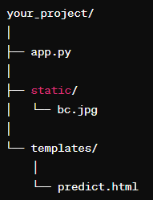

**Open app.py in visual studio**. Make sure all the necessary libraries and extensions are there. Next **run and debug** the file.

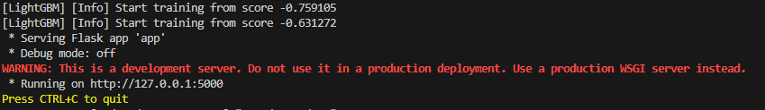

From the terminal copy this link and paste it in any web browser.

Enter the values in the UI page and click on **predict** button. To clear the page click on **clear** button.